Bearing (Shock Pulse) Condition Analyzer BVT-111N

**Four Instruments in one**

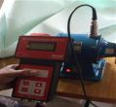

Bearing Condition & Noise Monitoring Machine Vibration Monitoring Rotational Speed

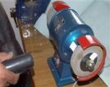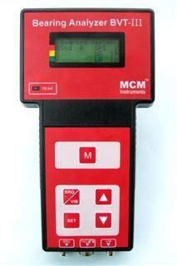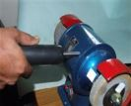

FEATURES

• Direct indication of machine condition in terms of good – reduced – bad in condition scale

• Detect mechanical condition of bearings

• Damage severity readings of bearings

• Detecting lubrication condition of ball-and-roller- type

Bearings

• Non-contact measurements of rotational speed

• Vibration Measurements according to ISO

recommendations.

\***Electronic stethoscope(Noise**)

MCM Presents a small Micro Processor based diagnostic tool for comprehensive condition analysis of rotating machinery.

Objective measurements of machine condition are needed as a reliable base for preventive maintenance. Now maintenance personal can **analyze bearing condition**, **measure machine vibration** and **check rotational speed** - with a single and easy to use instrument.

The best way is to periodically monitor bearing condition and replace the bearing at the right time by least influencing the production efficiency.

The need to eavesdrop on mechanical sounds within machinery is essential in any maintenance department. Mechanical faults can often be heard. The problem is to locate the sound source quickly and accurately in a generally noisy environment.

The electronic stethoscope is a sensitive listening stick, for location of all kinds of machinery noise. Valve chatter, tappet noise, piston slap, gear and pump noise and the operation of relays and solenoids are just a few of the many noises that may be traced, amplified and assessed with this device.

**Technical Specifications:**

|  |  |  |  |
| --- | --- | --- | --- |
| Bearing Tester Function |  | **Laser Tachometer**  **Function** |  |
| * Measuring range (Shock Pulse) | -19 - 100 dBpv | * Measuring range | 10 to 20000 RPM |
| * Resolution | 1 dBpv | *Measuring Distance | 10 feet |
| **Vibration Tester Function** |  | * Resolution | 1 rpm |
| * Measuring Range | 0.1 to 99.9mm/s RMS | * Temperature range | 0oC to 50oC |
| * Resolution | 0.1 mm/s | * Display | 16x4 line Dot Matrix LCD |
| * Accuracy | +/- (2% + 0.1 mm/s) | * Keypad | Seale membrane |
| \***Electronic Stethoscope (Noise)** | With Head phone |  |  |

|  |  |
| --- | --- |
| https://pmequipments.com/assets/img/pm_equipments_logo.png | **PREDICTIVE MEASURING EQUIPMENTS**  Plot No 146, Phase 1, Mytrinagar, Madinaguda, Hyderabad – 500049  Mobile: +91-90593 40351, eMail: info@pmequipments.com, www.pmequipments.com |